**CENWP-OD-B 07/19/2023**

**MEMORANDUM FOR THE RECORD**

**SUBJECT: 23BON061 MFR Bradford Island Pacific Lamprey Tube Trap Mortality**

On Thursday afternoon 19 July 2023 CRITFC staff found one Pacific Lamprey mortality in one of the Bradford Island tube traps. The fish was collected at Bonneville Dam on 19 July for the CRITFC-Tribal translocation program. The cause of death is unknown, photos of the fresh mortality were taken at the time of removal from the trap and are attached. The individual was scanned for PIT tags and frozen for potential future pathogen evaluation.

1. Species – Pacific Lamprey (*Entosphenus tridentatus*)
2. Origin – unknown
3. Length – 53.3 cm
4. Marks and tags – none
5. Marks and Injuries found on carcass – none
6. Cause and Time of Death – unknown
7. Future and Preventative Measures – none

*.*

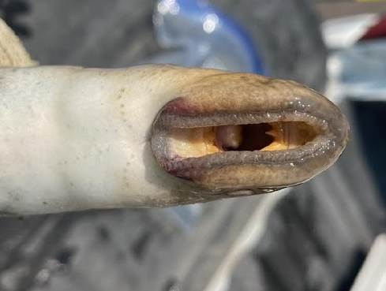

Sincerely,

Bonneville Project Fisheries

